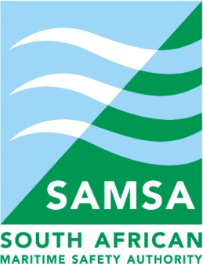
ANNEX 17

DOCTOR’S CERTIFICATE ON PRESCRIBED FORM
Candidates applying for a National Small Vessel Certificate of Competency are required to show that they are of sound mental health and are physically fit. Candidates, that require certificates of competency for under 9 metre vessels, may demonstrate their fitness by having this form completed by any doctor who is a member of the South African Medical Association.
Particulars of Candidate
Surname: | First Names:
ID Number:
(Positive ID to be produced)
Address:

1. Eyesight Test

The eyesight test shall comprise a letter test and the “Ishihara” card test for colour-blindness.
The tests can be conducted by any Doctor or Optometrist.

The letter test
Shall be conducted on Snellen’s principle by means of sheets which will contain 6 lines, the 3rd, 4th, 5th, and 6th lines corresponding to standards 6/24, 6/18, 6/12 and 6/9 respectively, and the candidate will be required to read correctly down to and including line 6, with either or both eyes, with or without aids to vision.

TEST RESULT | PASS | FAIL | COMMENT | DOCTOR OR OPTOMETRIST  SIGNATURE:
Only for Night Operation
The “Ishihara” card test
Is the test that is specified in the booklet entitled; “The Series of Plates designed as Tests for Colour-Blindness by Doctor Shinobu Ishihara”. [Plates 1, 11, 15, 22, AND 23]

NOTE: An examination candidate who is colour blind shall be limited to Day Skipper Certification. No aids to vision to correct colour-blindness deficiencies are permitted.

TEST RESULT | PASS | FAIL | COMMENT | DOCTOR OR OPTOMETRIST  SIGNATURE:

I, the undersigned medical practitioner, have positively identified and examined the candidate and find as follows:

Particulars of Doctor or Optometrist that has conducted the above tests.
Name (Printed):  Signature:  Contact telephone Numbers:(w) | Date of Examination: (Certificate valid for one year)  Address of Practice:

2. Medical Certificates

In terms of Regulation 17 of the National Small Vessel Safety Regulations, no person may operate a vessel if he or she is not physically able to do so and not of sound mental health.

I, the undersigned medical practitioner, have positively identified and examined the candidate and find as follows:

 | NATURE OF FITNESS LEVEL  (* Delete the fitness level that is not applicable.) | Signature of Doctor (where applicable)
1. | The candidate has no condition or disability which may affect his or her ability to operate a small vessel; or *
2. | The candidate may only operate a small vessel during daylight hours or on short excursions only; or *
3. | Any other limitation or comment. *

Particulars of Doctor that has conducted the above tests.
Name and Surname:  Signature:  Contact telephone Numbers:  (w) | Date of Examination: (Certificate valid for one year)  Address of Practice:

